Bank Marketing Campaign Case Study
- Executive Summary
The balanced logistic regression model provided the highest overall performance in predicting likelihood of customer acquisition as a result of marketing campaigns. The LDA model provided nearly similar results, confirming that linear decision boundaries effectively separate subscribers from non-subscribers in this domain. An ROI simulation revealed that there is potential for substantial efficiency improvement in shifting from a mass-marketing campaign focus to a more targeted approach using predictive modeling. Targeting just the top 10% most likely to subscribe individuals increases ROI to 45.2% while capturing 252 conversions with only 273 contacts.
The most powerful features in predicting probability of positive customer response are contract month, macroeconomic indicators, and contact type. Contact frequency exhibited diminishing returns with each additional call reducing subscription odds by 4.1%. We recommend implementing the balanced logistic regression model for prospect scoring, concentrating on specific months, such as March, and limiting contacts to 2-3 attempts per customer.
- The Problem
A mid-sized European retail bank runs continuous marketing campaigns to encourage customers to open long-term deposit accounts. The campaign utilizes multiple methods to attract customers, including phone calls, emails, and in-branch outreach. These campaigns are historically volatile and yield suboptimal positive customer response rates. Because of this, the bank’s goal is to develop a more targeted marketing campaign approach that will focus efforts and resources on customers that are likely to respond to the campaign, which will hopefully improve return on investment (ROI). The task we were assigned in this case study was to improve campaign efficiency by identifying which customers are most likely to subscribe. The objective of this research is to develop and evaluate predictive models that take data on individual customers, as well as broader market condition data, to predict which customers are most likely to subscribe to the term deposits. This information will help determine which marketing strategies are the best to maximize return on investment, as well as help the bank understand which features are most (and least) important in identifying potential customers.

Some of the questions that we plan to answer are: a) which model provides the highest predictive accuracy for subscription? b) What are the most significant factors that influence subscription likelihood. And c) does a balanced data set improve performance. We hypothesize that models trained on balanced data sets will demonstrate a superior performance in identifying positive subscription cases compared to the imbalanced dataset. We also anticipate that previous campaign contact history and outcomes will be a strong predictor of future subscriptions. Finally, we hypothesize that random forest models will achieve the highest overall accuracy since they can capture any nonlinear relationships and interactions, although logistic regression may provide a better interpretability. The remainder of this report will discuss a brief introduction into literature related to predictive modeling in direct marketing context, followed by a discussion of the methodology used, the steps required to process the data (data cleaning and preprocessing procedures), and then a presentation of the findings, which will include model performance and ROI simulations.

- Review of Related Literature
Classification models being used for customer response prediction have evolved significantly, with researchers comparing traditional statistical methods against newer approaches. Moro, Cortez, and Rita¹ (2014) conducted research and found that support vector machines achieved the highest performance, although their work did not explore random forest and did not balance sampling approaches as we did here. Random forests were introduced by Leo Breiman in 2001², and have shown promise in marketing analytics due to their ability to handle nonlinear relationships and capture interaction effects without explicit specifications. The method constructs multiple decision trees using bootstrapped samples and random feature subsets at each split, then it aggregates predictions through majority voting. This approach reduces overfitting compared to a single decision tree while also maintaining interpretability. Neslin et al. (2006) developed lift analysis techniques that evaluate model performance in terms of campaign ROI rather than statistical metrics by themselves.

- Methodology
In this case study, we will compare the results of four classification methods: logistic regression, linear discriminant analysis (LDA), decision tree, and random forest. Logistic regression is a parametric model that will assume a linear relationship between predictors and the log-odds of subscription. Due to multicollinearity concerns, variance inflation factors (VIF) were calculated, which lead to the removal of “emp.var.rate” and “euribor3m,” which represent the employee variance rate within the bank and the Euribor 3-month rate, respectively. The reduced model maintained all VIF values below 5.0, satisfying the multicollinearity assumptions.

LDA is a parametric classification method that assumes multivariate normality within each class and estimates a linear decision boundary that maximally separates the two groups. LDA projects the predictors onto a lower-dimensional space while preserving class separability. Due to zero within-class variance for housing and loan variables in some groups, these predictors were excluded from the LDA models, which illustrates a limitation of LDA compared to logistic regression.

Decision tree is a non-parametric model that classifies observations through binary splits based on predictor values. The trees were grown using the CART algorithm with default complexity parameter settings which allowed the model to determine optimal tree depth through cross validation.

Random forest is an ensemble method composed of many decision trees, each of which is trained on bootstrapped samples with random subsets of predictors considered at each split. For the balance dataset, mtry was set to 3 and for the imbalanced default mtry was used. Node size was set to 50 to prevent overfitting, and 150 trees were used.

An imbalanced and a balanced dataset were developed to handle and address class imbalance. The imbalanced dataset is the full dataset of 41,188 observations. This was split 70/30 into training and test sets using random sampling to maintain class distribution. The balanced dataset retained all positive cases and an equal number of negative cases which were randomly sampled from negative observations. This balanced dataset was then split into a 70/30 training test set. The model evaluation will be evaluated by classification accuracy, sensitivity, specificity, area under the ROC curve (AUC), and confusion matrices. Also, the ROI simulation will be conducted to translate model predictions into economic values. Using cost parameters of $5 per contact and $250 per successful subscription, three targeting strategies were compared, mass marketing, targeting top 20% of scored prospects, and targeting top 10% of scored prospects.

- Data
The initial dataset contained 41,188 observations across 21 variables, with no missing values in the raw data. However, several data issues needed to be resolved. First, several categorical variables needed to be converted from character strings to factor types for proper modeling. These included job, marital, education, default, housing, loan, contract, month, day_of_week, poutcome, and the response variable y. We also ordered factor levels of the three variables education, month, and day_of_week. Three variables (duration, pdays, and poutcome) were excluded from the predictive modeling. The variable “duration” (call duration in seconds) was removed because it is a near perfect predictor that would not be available before contact. The variable “pdays” (days since previous contact) was excluded due to the extreme sparsity, 96.3% of the observations had values of 999 indicating that there was no previous contact. The variable “poutcome” was transformed into two derived features: “prev_contacted” and “prev_outcome.” However, prev_outcome showed perfect collinearity with other predictors and was ultimately dropped. Specifically, the subset of observations, where loan = unknown, exhibited singular covariance structure with prev_outcome, necessitating removal of both variables. After filtering out loan = unknown and dropping prev_outcome, the final dataset contained no multicollinearity issues.

It was revealed that there were severe multicollinearity among the macroeconomic variables emp.var.rate, euribor3m, and nr.employed. These variables were removed one at a time based on highest VIF until all values fell below 5.0. The final model excluded emp.var.rate and euribor3m but kept nr.employed. This reduction was necessary only for logistic regression. Tree based methods are inherently robust to multicollinearity.

Some of the limitations we experienced were that there was a severe class imbalance. The 88% negative / 11% positive split created challenges for model training such that a model may improve its accuracy score simply by acquiring bias for predicting the majority class (negative), which would undermine the sensitivity score in the case of this dataset . We addressed this through balancing the dataset with the below code. Another unfortunate limitation is that the data spans from 2008 to 2010, which coincides with a global financial crisis, potentially distorting insights meant to be applied to more normal economic conditions.
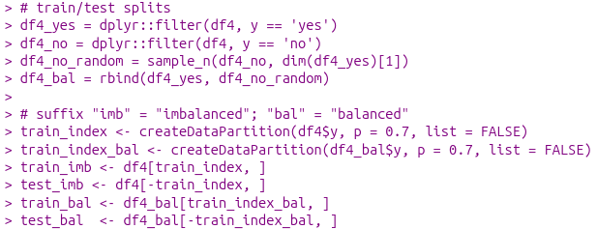
- Findings (Results)
After training all four classification models with both the balanced and imbalance datasets, we found that three models were tied for the highest AUC (0.79): the logistic regression trained on balanced data, the LDA trained on balanced data, and the decision tree trained on balanced data. The random forest model trained on balanced data lagged only slightly behind with an AUC of 0.785.

Model | Dataset | Accuracy | Sensitivity | Specificity | AUC
Logistic Regression | Balanced | 74.2% | 62.6% | 85.6% | 0.790
Logistic Regression | Imbalanced | 89.1% | 17.6% | 98.2% | 0.780
LDA | Balanced | 74.0% | 62.3% | 85.6% | 0.790
LDA | Imbalanced | 87.9% | 43.8% | 93.6% | 0.760
Decision Tree | Balanced | 74.4% | 60.8% | 87.8% | 0.790
Decision Tree | Imbalanced | 89.1% | 19.7% | 98.0% | 0.780
Random Forest | Balanced | 73.3% | 61.7% | 84.8% | 0.785
Random Forest | Imbalanced | 89.4% | 22.6% | 97.9% | 0.754

One of the most significant findings was that the balanced datasets outperformed the imbalanced datasets by a significant amount. This suggests that linear decision boundaries effectively separate subscribers from non-subscribers, and that the relationship between the predictors and outcomes are additive without complex interactions. The large spread in sensitivity/specificity scores when comparing one model type trained on balanced versus imbalanced data demonstrates the bias that the model learns when training on imbalanced data by over-predicting the majority class label (negative, or ‘no’), even if it sacrifices sensitivity to do so. For this situation where identifying a potential subscriber is the objective, the balanced models’ performances appear more desirable despite the slightly lower overall accuracy.

Using the balanced logistic regression model coefficients, we can estimate which features are most likely to influence subscriptions likelihood, as seen below.

Variable | Coefficient | P-value | Direction
Month: March | 1.745 | < 0.001 | Positive
Employed | 0.0088 | 0.058 | Positive
Month: August | 0.767 | < 0.001 | Positive
Contact: Telephone | -0.699 | < 0.001 | Negative
Month: June | -0.739 | < 0.001 | Negative
Consumer Confidence Index | 0.0462 | 0.001 | Positive
Number of Contacts | -0.0419 | 0.003 | Negative

Contact month was shown to be the strongest predictor, with March campaigns having the highest subscriptions rates. Contacts made during the month of June performed worse, which suggest that there could be seasonal patterns in customer receptiveness. Further, campaign intensity (measured in number of contacts) showed a negative relationship. Each additional contact on an individual reduced the odds of them subscribing, suggesting that repeated contact could diminish returns.
The balanced decision tree model has a primary split that occurs at nr.employed = 5,088. The decision tree provided insights such as 72% of observations fall into the higher employment segment with only 36% predicted to subscribe. Lower employment showed 28% of observations with 85% predicted to subscribe. The higher employment segment splits further on month. The decision tree showed that contacts made in August, December, July, June, May, and November were less likely to subscribe (32% subscription). The lower employment segment does not split further, suggesting that lower employment level alone is sufficient to predict higher subscription probability.

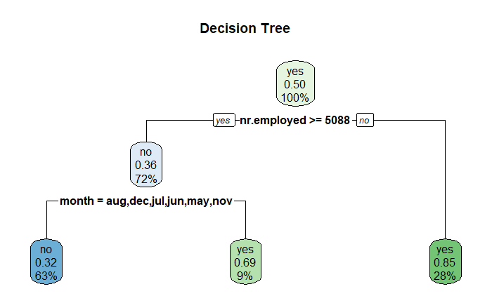

The ROI simulation assessed the business value of predictive targeting. We simulated three strategies using the balanced logistic regression model. The first being mass marketing which is contacting all prospects. Second, targeting the top 20% ranked by subscription probability. Third, contacting only the top 10% of prospects, again ranked by predicted subscription probability. We assume a contact cost of $5 per call and revenue of $250 per successful subscription.
Strategy | Contacts | Conversions | Cost | Revenue | ROI
Mass Marketing | 2,723 | 1.351 | $13,615 | $337,750 | 23.8
Top 20% | 545 | 481 | $2,725 | $120,250 | 43.1
Top 10% | 273 | 252 | $1,365 | $63,000 | 45.2

According to the ROI simulation, the targeting strategies dramatically improved campaign efficiency. The top 10% targeting strategy achieved 90% reduction in contacts, 81% reduction in costs, 19% of total possible conversions capture, 90% higher ROI, and conversion rate of 92.3% among contacted prospects. From these results, we may surmise that the bank may achieve nearly double the return on marketing expenditures while reducing customer contact burden and also improving both financial performance and customer experience.

- Conclusions
Our analysis of this data demonstrated that predictive modeling can improve direct marketing campaign effectiveness for term deposit products. The balanced logistic regression model emerged as the optimal approach by achieving a 0.79 AUC with strong balance between sensitivity (62.6%) and specificity (85.6%). Also, contact timing (March) represents the strongest single predictive factor, possibly implying some seasonal variations in customer receptiveness. Some macroeconomic conditions such as consumer confidence and employment levels also influenced the subscription decision. Further, the economic analysis revealed that selective targeting based on model prediction can achieve 90% higher ROI compared to mass marketing approaches. These findings have immediate implications for campaign design and resource allocation.
Based on the findings, we would recommend that the balanced logistic regression is deployed in production to score all prospects before campaign launches. Concentrate on marketing efforts in March when subscription rates are highest and avoid June unless targeting a niche segment. Implement a contact frequency cap of 2-3 attempts per customer per campaign period. Finally, adjust campaign intensity based on macroeconomic conditions and increase effort when customers’ confidence is rising and employment is stable.
Some alternative methods that could be used are neural networks. Deep learning models with appropriate regularization could identify nonlinear patterns that are difficult to capture by traditional methods. However, the limited sample size may constrain the effectiveness.

- Appendix

- https://www.sciencedirect.com/science/article/abs/pii/S016792361400061X
- https://link.springer.com/article/10.1023/A:1010933404324
- https://www.researchgate.net/publication/228617330_Defection_Detection_Measuring_and_Understanding_the_Predictive_Accuracy_of_Customer_Churn_Models

Logistic regression model training/results
> test_bal5$prob_lr <- predict(lr_model_bal5, newdata = test_bal5, type = "response")
> test_bal5$pred_lr <- ifelse(test_bal5$prob_lr > 0.5, "yes","no") %>% factor(levels=c("no","yes"))
>
> test_imb5$prob_lr <- predict(lr_model_imb5, newdata = test_imb5, type = 'response')
> test_imb5$pred_lr <- ifelse(test_imb5$prob_lr > 0.5, 'yes', 'no') %>% factor(levels = c('no', 'yes'))
>
> # ROC curve, AUC calculation, confusion matrix
> roc_lr_bal <- roc(test_bal5$y, test_bal5$prob_lr)
> auc_lr_bal <- roc_lr_bal$auc
> print(confusionMatrix(test_bal5$pred_lr, test_bal5$y, positive = "yes"))
Confusion Matrix and Statistics

Reference
Prediction no yes
no 1175 505
yes 197 846

Accuracy : 0.7422
95% CI : (0.7253, 0.7585)
No Information Rate : 0.5039
P-Value [Acc > NIR] : < 2.2e-16

Kappa : 0.4835

Mcnemar's Test P-Value : < 2.2e-16

Sensitivity : 0.6262
Specificity : 0.8564
Pos Pred Value : 0.8111
Neg Pred Value : 0.6994
Prevalence : 0.4961
Detection Rate : 0.3107
Detection Prevalence : 0.3830
Balanced Accuracy : 0.7413

'Positive' Class : yes

>
> roc_lr_imb <- roc(test_imb5$y, test_imb5$prob_lr)
> auc_lr_imb <- roc_lr_imb$auc
> print(confusionMatrix(test_imb5$pred_lr, test_imb5$y, positive = 'yes'))
Confusion Matrix and Statistics

Reference
Prediction no yes
no 10497 1123
yes 188 240

Accuracy : 0.8912
95% CI : (0.8855, 0.8967)
No Information Rate : 0.8869
P-Value [Acc > NIR] : 0.06867

Kappa : 0.2262

Mcnemar's Test P-Value : < 2e-16

Sensitivity : 0.17608
Specificity : 0.98241
Pos Pred Value : 0.56075
Neg Pred Value : 0.90336
Prevalence : 0.11313
Detection Rate : 0.01992
Detection Prevalence : 0.03552
Balanced Accuracy : 0.57924

'Positive' Class : yes

Decision Tree Training/results

> tree_ml <- formula_lr
> tree_model_bal <- rpart(tree_ml, data = train_bal5, method = 'class')
> tree_model_imb <- rpart(tree_ml, data = train_imb5, method = 'class')
>
> rpart.plot(tree_model_bal, main = 'Decision Tree (Balanced Data)')
> rpart.plot(tree_model_imb, main = 'Decision Tree (Imbalanced Data)')
>
> test_bal5$prob_tree <- predict(tree_model_bal, newdata = test_bal5)[,"yes"]
> test_bal5$pred_tree <- ifelse(test_bal5$prob_tree > 0.5,"yes","no") %>% factor(levels=c("no","yes"))
> test_imb5$prob_tree <- predict(tree_model_imb, newdata = test_imb5)[,'yes']
> test_imb5$pred_tree <- ifelse(test_imb5$prob_tree > 0.5,'yes','no') %>% factor(levels = c('no', 'yes'))
>
> roc_tree_bal <- roc(test_bal5$y, test_bal5$prob_lr)
> auc_tree_bal <- roc_tree_bal$auc
> print(confusionMatrix(test_bal5$pred_tree, test_bal5$y, positive = 'yes'))
Confusion Matrix and Statistics

Reference
Prediction no yes
no 1204 529
yes 168 822

Accuracy : 0.744
95% CI : (0.7272, 0.7603)
No Information Rate : 0.5039
P-Value [Acc > NIR] : < 2.2e-16

Kappa : 0.487

Mcnemar's Test P-Value : < 2.2e-16

Sensitivity : 0.6084
Specificity : 0.8776
Pos Pred Value : 0.8303
Neg Pred Value : 0.6947
Prevalence : 0.4961
Detection Rate : 0.3019
Detection Prevalence : 0.3636
Balanced Accuracy : 0.7430

'Positive' Class : yes

>
> roc_tree_imb <- roc(test_imb5$y, test_imb5$prob_lr)
> auc_tree_imb <- roc_tree_imb$auc
> print(confusionMatrix(test_imb5$pred_tree, test_imb5$y, positive = 'yes'))
Confusion Matrix and Statistics

Reference
Prediction no yes
no 10470 1095
yes 215 268

Accuracy : 0.8913
95% CI : (0.8856, 0.8968)
No Information Rate : 0.8869
P-Value [Acc > NIR] : 0.0649

Kappa : 0.2457

Mcnemar's Test P-Value : <2e-16

Sensitivity : 0.19663
Specificity : 0.97988
Pos Pred Value : 0.55487
Neg Pred Value : 0.90532
Prevalence : 0.11313
Detection Rate : 0.02224
Detection Prevalence : 0.04009
Balanced Accuracy : 0.58825

'Positive' Class : yes
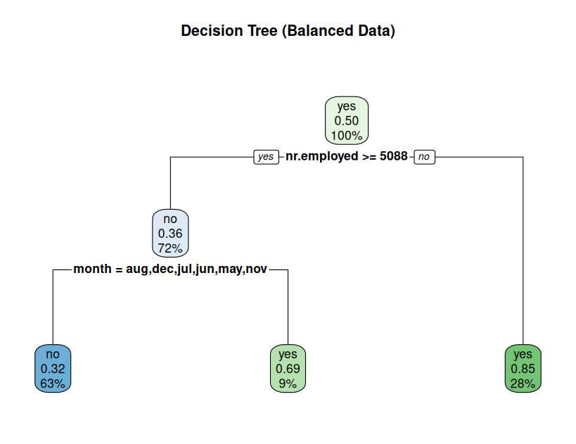
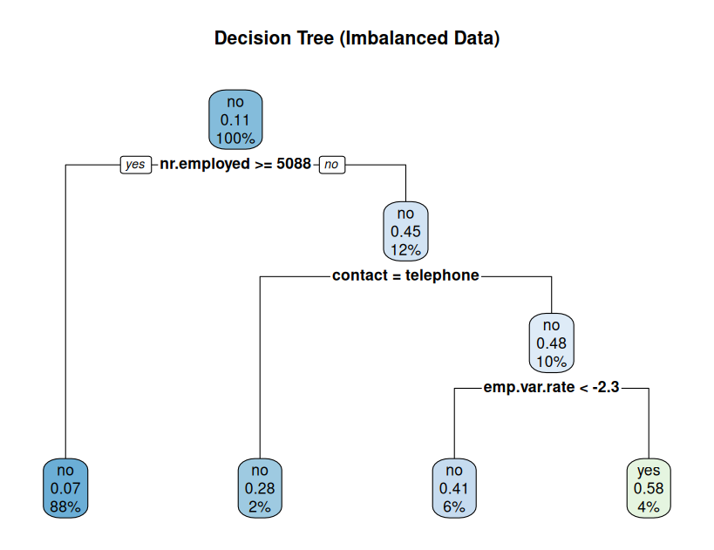
Random Forest training/results
> # because randomForest() requires the lengths of x and y to be identical, we need to drop rows with any na values. using the following x and y variable assignments solves that problem
> mf_bal <- model.frame(formula_lr3, data = train_bal5, na.action = na.omit)
> x_bal <- model.matrix(formula_lr3, data = mf_bal)[, -1]
> y <- mf_bal$y
>
> rf_model_bal <- randomForest(x = x_bal,
+ y = y,
+ ntree = 150,
+ mtry = floor(sqrt(length(all.vars(formula_lr3)))),
+ nodesize = 50,
+ importance = TRUE)
> varImpPlot(rf_model_bal, main = 'Random Forest Importance (balanced)')
>
> mf_imb <- model.frame(formula_lr3, data = train_imb5, na.action = na.omit)
> x_imb <- model.matrix(formula_lr3, data = mf_imb)[, -1]
> y <- mf_imb$y
>
> rf_model_imb <- randomForest(x = x_imb,
+ y = y,
+ ntree = 150,
+ nodesize = 50,
+ importance = TRUE)
> varImpPlot(rf_model_imb, main = 'Random Forest Importance (imbalanced)')
>
> # creating test prob and test predict
> mf_test_bal <- model.frame(formula_lr3, data = test_bal5, na.action = na.omit)
> test_mm_bal <- model.matrix(formula_lr3, data = mf_test_bal)[,-1]
>
> mf_test_imb <- model.frame(formula_lr3, data = test_imb5, na.action = na.omit)
> test_mm_imb <- model.matrix(formula_lr3, data = mf_test_imb)[,-1]
>
> mf_test_bal$prob_rf <- predict(rf_model_bal, newdata = test_mm_bal, type = "prob")[, "yes"]
> mf_test_bal$pred_rf <- ifelse(mf_test_bal$prob_rf > 0.5, 'yes', 'no') %>%
+ factor(levels = c('yes', 'no'))
>
> mf_test_imb$prob_rf <- predict(rf_model_imb, newdata = test_mm_imb, type = 'prob')[, 'yes']
> mf_test_imb$pred_rf <- ifelse(mf_test_imb$prob_rf > 0.5, 'yes', 'no') %>%
+ factor(levels = c('yes', 'no'))
>
> # ROC and AUC metrics
>
> roc_rf_bal <- roc(mf_test_bal$y, mf_test_bal$prob_rf)
> auc_rf_bal <- roc_rf_bal$auc
> roc_rf_imb <- roc(mf_test_imb$y, mf_test_imb$prob_rf)
> auc_rf_imb <- roc_rf_imb$auc
>
> print(confusionMatrix(mf_test_bal$pred_rf, mf_test_bal$y, positive = 'yes'))
Confusion Matrix and Statistics

Reference
Prediction no yes
no 1187 529
yes 185 822

Accuracy : 0.7378
95% CI : (0.7208, 0.7542)
No Information Rate : 0.5039
P-Value [Acc > NIR] : < 2.2e-16

Kappa : 0.4745

Mcnemar's Test P-Value : < 2.2e-16

Sensitivity : 0.6084
Specificity : 0.8652
Pos Pred Value : 0.8163
Neg Pred Value : 0.6917
Prevalence : 0.4961
Detection Rate : 0.3019
Detection Prevalence : 0.3698
Balanced Accuracy : 0.7368

'Positive' Class : yes

> print(confusionMatrix(mf_test_imb$pred_rf, mf_test_imb$y, positive = 'yes'))
Confusion Matrix and Statistics

Reference
Prediction no yes
no 10468 1044
yes 217 319

Accuracy : 0.8953
95% CI : (0.8897, 0.9007)
No Information Rate : 0.8869
P-Value [Acc > NIR] : 0.001598

Kappa : 0.2907

Mcnemar's Test P-Value : < 2.2e-16

Sensitivity : 0.23404
Specificity : 0.97969
Pos Pred Value : 0.59515
Neg Pred Value : 0.90931
Prevalence : 0.11313
Detection Rate : 0.02648
Detection Prevalence : 0.04449
Balanced Accuracy : 0.60687

'Positive' Class : yes

>
> print(paste("Random Forest AUC (balanced): ", auc_rf_bal))
[1] "Random Forest AUC (balanced): 0.785590470723554"
> print(paste("Random Forest AUC (imbalanced): ", auc_rf_imb))
[1] "Random Forest AUC (imbalanced): 0.758585911297679"

LDA Model Training/results
> # variables 'housing' and 'loan' are excluded in the model due to lda's inability to train on variables with zero variance within one or more classes
> lda.model_bal <- lda(y ~ . -housing - loan, data = train_bal5)
> lda.model_imb <- lda(y ~ . - housing - loan, data = train_imb5)
>
> # predictions
> lda_bal_preds <- predict(lda.model_bal, test_bal5)
> lda_imb_preds <- predict(lda.model_imb, test_imb5)
>
> # confusion matrices
> caret::confusionMatrix(as.factor(lda_bal_preds$class), as.factor(test_bal5$y))
Confusion Matrix and Statistics

Reference
Prediction no yes
no 1174 509
yes 198 842

Accuracy : 0.7404
95% CI : (0.7235, 0.7567)
No Information Rate : 0.5039
P-Value [Acc > NIR] : < 2.2e-16

Kappa : 0.4798

Mcnemar's Test P-Value : < 2.2e-16

Sensitivity : 0.8557
Specificity : 0.6232
Pos Pred Value : 0.6976
Neg Pred Value : 0.8096
Prevalence : 0.5039
Detection Rate : 0.4311
Detection Prevalence : 0.6181
Balanced Accuracy : 0.7395

'Positive' Class : no

> caret::confusionMatrix(as.factor(lda_imb_preds$class), as.factor(test_imb5$y))
Confusion Matrix and Statistics

Reference
Prediction no yes
no 9996 766
yes 689 597

Accuracy : 0.8792
95% CI : (0.8733, 0.885)
No Information Rate : 0.8869
P-Value [Acc > NIR] : 0.99584

Kappa : 0.383

Mcnemar's Test P-Value : 0.04632

Sensitivity : 0.9355
Specificity : 0.4380
Pos Pred Value : 0.9288
Neg Pred Value : 0.4642
Prevalence : 0.8869
Detection Rate : 0.8297
Detection Prevalence : 0.8933
Balanced Accuracy : 0.6868

'Positive' Class : no

ROI Simulation
> # ROI Simulation
>
> cost_per_contact <- 5
> revenue_per_conversion <- 250
>
> simulate_roi <- function(df_probs, prob_col = "prob"){
+ n_total <- nrow(df_probs)
+
+ # Mass marketing
+ mass_contacts <- n_total
+ mass_conversions <- sum(as.numeric(as.character(df_probs$y_num)))
+ mass_cost <- mass_contacts * cost_per_contact
+ mass_revenue <- mass_conversions * revenue_per_conversion
+ mass_roi <- (mass_revenue - mass_cost) / mass_cost
+
+ # Top 20%
+ top20_n <- ceiling(0.20 * n_total)
+ top20 <- df_probs %>% arrange(desc(.data[[prob_col]])) %>% slice(1:top20_n)
+ top20_conversions <- sum(as.numeric(as.character(top20$y_num)))
+ top20_cost <- top20_n * cost_per_contact
+ top20_revenue <- top20_conversions * revenue_per_conversion
+ top20_roi <- (top20_revenue - top20_cost) / top20_cost
+
+ # Top 10%
+ top10_n <- ceiling(0.10 * n_total)
+ top10 <- df_probs %>% arrange(desc(.data[[prob_col]])) %>% slice(1:top10_n)
+ top10_conversions <- sum(as.numeric(as.character(top10$y_num)))
+ top10_cost <- top10_n * cost_per_contact
+ top10_revenue <- top10_conversions * revenue_per_conversion
+ top10_roi <- (top10_revenue - top10_cost) / top10_cost
+
+ tibble(
+ scenario = c("Mass (all)", "Target top 20%", "Target top 10%"),
+ contacts = c(mass_contacts, top20_n, top10_n),
+ conversions = c(mass_conversions, top20_conversions, top10_conversions),
+ cost = c(mass_cost, top20_cost, top10_cost),
+ revenue = c(mass_revenue, top20_revenue, top10_revenue),
+ ROI = c(as.numeric(mass_roi), as.numeric(top20_roi), as.numeric(top10_roi))
+ )
+ }

> roi_lr <- simulate_roi(test_imb6 %>% rename(prob = prob_lr))
> roi_lr_bal <- simulate_roi(test_bal6 %>% rename(prob = prob_lr))
>
> roi_lda <- simulate_roi(test_imb6 %>% rename(prob = probs_lda))
> roi_lda_bal <- simulate_roi(test_bal6 %>% rename(prob = probs_lda))
>
> roi_tree <- simulate_roi(test_imb6 %>% rename(prob = prob_tree))
> roi_tree_bal <- simulate_roi(test_bal6 %>% rename(prob = prob_tree))
>
> roi_rf <- simulate_roi(mf_test_imb_2 %>% rename(prob = prob_rf))
> roi_rf_bal <- simulate_roi(mf_test_bal_2 %>% rename(prob = prob_rf))
>
>
>
> print(list(Logistic = roi_lr, Balanced_Logistic = roi_lr_bal,
+ LDA = roi_lda, Balanced_LDA = roi_lda_bal,
+ Tree = roi_tree, Balanced_Tree = roi_tree_bal,
+ RF = roi_rf, Balanced_RF = roi_rf_bal))
$Logistic
# A tibble: 3 × 6
scenario contacts conversions cost revenue ROI
<chr> <dbl> <dbl> <dbl> <dbl> <dbl>
1 Mass (all) 12048 1363 60240 340750 4.66
2 Target top 20% 2410 834 12050 208500 16.3
3 Target top 10% 1205 570 6025 142500 22.7

$Balanced_Logistic
# A tibble: 3 × 6
scenario contacts conversions cost revenue ROI
<chr> <dbl> <dbl> <dbl> <dbl> <dbl>
1 Mass (all) 2723 1351 13615 337750 23.8
2 Target top 20% 545 481 2725 120250 43.1
3 Target top 10% 273 252 1365 63000 45.2

$LDA
# A tibble: 3 × 6
scenario contacts conversions cost revenue ROI
<chr> <dbl> <dbl> <dbl> <dbl> <dbl>
1 Mass (all) 12048 1363 60240 340750 4.66
2 Target top 20% 2410 831 12050 207750 16.2
3 Target top 10% 1205 570 6025 142500 22.7

$Balanced_LDA
# A tibble: 3 × 6
scenario contacts conversions cost revenue ROI
<chr> <dbl> <dbl> <dbl> <dbl> <dbl>
1 Mass (all) 2723 1351 13615 337750 23.8
2 Target top 20% 545 482 2725 120500 43.2
3 Target top 10% 273 250 1365 62500 44.8

$Tree
# A tibble: 3 × 6
scenario contacts conversions cost revenue ROI
<chr> <dbl> <dbl> <dbl> <dbl> <dbl>
1 Mass (all) 12048 1363 60240 340750 4.66
2 Target top 20% 2410 668 12050 167000 12.9
3 Target top 10% 1205 554 6025 138500 22.0

$Balanced_Tree
# A tibble: 3 × 6
scenario contacts conversions cost revenue ROI
<chr> <dbl> <dbl> <dbl> <dbl> <dbl>
1 Mass (all) 2723 1351 13615 337750 23.8
2 Target top 20% 545 545 2725 136250 49
3 Target top 10% 273 273 1365 68250 49

$RF
# A tibble: 3 × 6
scenario contacts conversions cost revenue ROI
<chr> <dbl> <dbl> <dbl> <dbl> <dbl>
1 Mass (all) 12048 1363 60240 340750 4.66
2 Target top 20% 2410 826 12050 206500 16.1
3 Target top 10% 1205 578 6025 144500 23.0

$Balanced_RF
# A tibble: 3 × 6
scenario contacts conversions cost revenue ROI
<chr> <dbl> <dbl> <dbl> <dbl> <dbl>
1 Mass (all) 2723 1351 13615 337750 23.8
2 Target top 20% 545 475 2725 118750 42.6
3 Target top 10% 273 244 1365 61000 43.7

